Abstract

The following document details the team’s efforts at creating a new exciting board game called “Mind Bogglers”. By combining the modern day video game “Block Breaker” with the classic board game “Carrom” a new and exciting experience was created.

Mind bogglers

Mohamed Ali Alsadig Mohamed, Krishna Samhitha Kanchi, Jason Andrew Shar, Meenakshi Nagarajan

Contents

1 Introduction 1

1.1 Mission Statement 1

1.2 General Product Description 2

1.3 Expected Customer Base 2

1.4 Project Milestones 2

2 Customer Requirements 4

2.1 Voice of the Customer 4

2.2 Translation to Customer Requirements 6

3 Project Planning 7

3.1 Customer Requirement Importance Weighting 7

3.2 Ranking Competitors 8

3.3 Benchmarking and Initial Market Plan 9

4 Technical Requirements 10

4.1 Product Performance Measures 10

4.2 Requirement Trade-Offs and Interactions 12

5 Design 12

5.1 Overview 12

5.2 Individual Aspects 14

5.2.1 Ability for Striker to Bounce 14

5.2.2 Striker Game Piece 16

5.2.3 Other Game Pieces 18

6 Final marketing plan 21

7 Test Plan 23

Appendix 1

# 

# Introduction

## Mission Statement

The mission statement plays a prominent role in the product development process. The input of process in development process is mission statement, therefore, it informs development process what is mission of the project. In addition, it considered as an output of the process when identifying the opportunities and product planning.

**Benefit Proposition:**

* The game board will be easy to play mechanics and simple to understand rules.
* Allows for hours of fun, and invention of new methods of play.
* Can be played competitively.
* Can be used for social entertainment.

**Key Business Goals:**

* Develop the product by early December to allow for adequate production ramp-up and marketing. Introduce product by early fall of next year to capture holiday shopping crowd.
* Sell 1000 units within the first year of production at a selling price less than $30.
* Serve as a platform on which more products can be made.
* Design a new board game that can be portable.

**Primary Market:**

* People interested in game board.
* Ages 12 and above.

**Secondary Market:**

* Nursing homes.
* Entertainment places (restaurants, public clubs)

**Assumptions and Constraints:**

**Assumptions:**

* The game is easy to learn and it has multiple levels.
* Customers will respond positively to the game.

**Constraints:**

* The project must be completed by the team before 8-Dec 2016.
* The game can be played by one or two players.

**Potential Problems/Obstacles:**

* Lack of resources and funding.
* Lack of development time.
* Market potential.
* Uncertainty in product acceptance during the Promotion.
* Developing a new game board that will attract people will be a challenge.

**Stakeholders:**

* Clients.
* Design team.
* Supervisor (Course Instructor).
* Quality assurance.

## General Product Description

A time limited (30 to 60 minutes) game for multiple players (2 players). It is simple and easy to play. The board game is derived from two game boards which are Carrom and Block Breaker. The board game will be interesting and attractive and will be used as a “kill time” board game.

## Expected Customer Base

After we developed the game from the simple idea to prototype and final product, our objective is to trade our game to our primary market.

## Project Milestones

**Team Charter:**

* Meenakshi Nagarajan.
* Jason Shar.
* Mohamed Mohamed.
* Krishna Samhita Kanchi.

**Team Roles and Responsibilities:**

* Organizing meetings and keeping team members informed of team activities.
* Making research based future projections by identifying the needs.
* Developing strategies for overcoming barriers.
* Evaluating deliverables.
* Conducting survey.
* On time completion

**Team Organizational Structure and Rules**

**Team Organizational Structure:**

* Team leader – Task allocation to team members, management of team, managing and tracking the plans of our team.
* Designer – Involved in product design and defines the technical requirements of the product, detailed design of product components.
* Documenter – takes care of design documentation and keep track of the changes in the document. This can be used for future reference.
* Quality auditor – Evaluates the product and check if the sticks to the requirements.

Rules:

* Tasks are rotated between members to introduce fresh ideas to the project and to prevent boredom.
* Equal participation.
* Quick conflict resolution.

**Individual Member Strengths/Skills Inventory:**

* Jason Shar – Expert in team management and motivation.
* Meenakshi – Rendering technical abilities
* Mohammed – Subject matter expert
* Krishna – Technical writing

**Milestones:**

The team set out to accomplish a series of milestones over a four-month period. These milestones are illustrated in Table 1. The primary objective was to complete the process relatively quickly and produce a quality product.

**Expectations:**

* All team members are expected to be genuinely committed to the work assigned
* Reliable and responsible.
* Participate and tackle challenges for the problems arise.
* All team members are also expected to be good learners.



Table 1 Detailed schedule of the semester's activities

* Regular weekly meeting on Wednesday.

**Success Criteria:**

* All our team members actively involved in the project and make the project successful.
* The introduction of the fun and exciting game with simple rules and regulations is implemented.

# Customer Requirements

## Voice of the Customer

After completion of the Mission Statement and Team Charter, the team began work on the next phases of the process: gathering customer feedback and assigning metrics. It was important that lead users of the game be identified early on, so that specific and latent needs could be discovered. We constructed a series of questions that we thought could best provide insight into potential needs. We tallied customer statements and converted them into needs. From there, we identified competing board games and sought to establish a benchmark with them. We ranked our game with respect to them, and created product specifications.

Beginning first with identifying users, the team struggled slightly at whom to ask. While the campus provides an ample population from which to select, it was unclear if we would identify lead users by random selection. To remedy this, one team member asked the club members of the Adventurer’s Guild, an on-campus board gaming club. These users would probably be the most to benefit from the creation of a new game, and offered excellent feedback. Our established users are the board gaming community, those with families and children, along with casual gamers. We identified most likely to contain lead users and surveyed the group.

To ensure enough quantity, another team member did set up an online questionnaire. The survey, conducted through Survey Monkey, would allow the team to receive multiple evaluations with different community. While there was some concern about the possible lack of quality such as it lacked detailed and explanative responses and online survey respondents did not answer each and every question that was posted. The team agreed that qualitative data could come from one-on-one interviews, while quantitative data would be the result of the interview. The one-on-one interview has the ability to capture a more quantitative sample of a larger population. So, one-one interviews would be more quantitative than survey.

With our users established, the team began thinking of possible questions to ask. The questions needed to reveal insight about the product to help with concept generation. As such, we selected a mix of qualitative and quantitative questions. The qualitative questions would support identification of latent, while the quantifiable questions allowed assigning specific scores to our needs measures.

Both the on-line and in person, questions revealed certain characteristics about the users. For instance, by asking in person we obtained in depth and general understanding of the answers since we got many follow up questions. Furthermore, by asking questions online, the results can be analyzed at any time. We observed an overwhelming response in certain questions, and varied responses in others. The results for the survey are shown in Figure 1.

## Translation to Customer Requirements

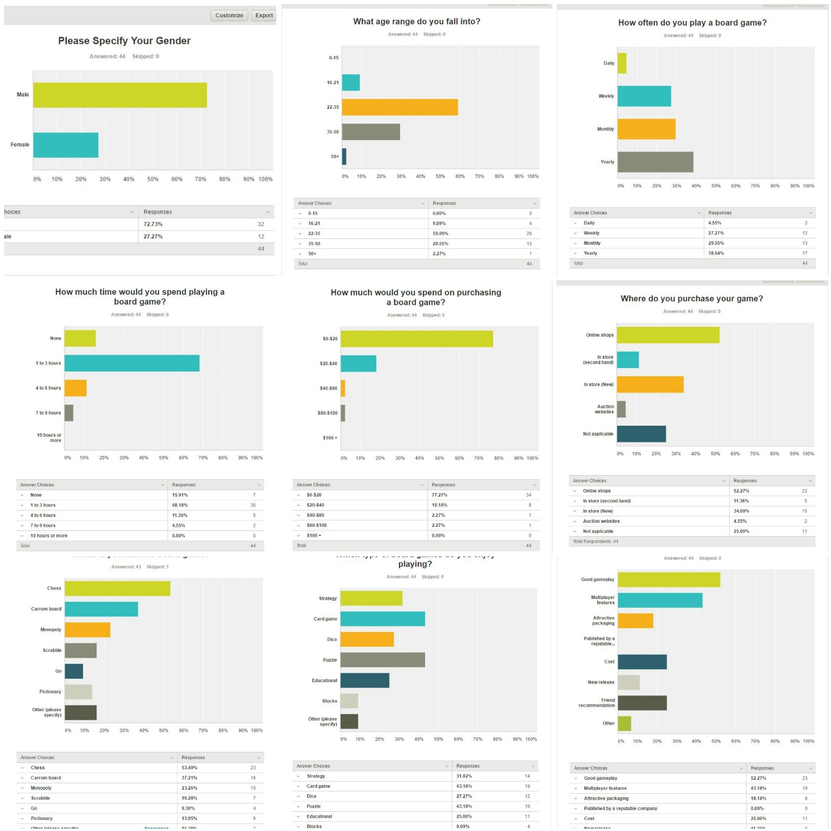

Figure 1 Survey results for the online questionaire

After acquiring the raw customer data, we converted the needs into design requirements. This was done mainly through assessing what the perceived need of the customer was through what they responded to. For instance, if a customer said, “I like multiplayer games”, the associated need was, “The game will be able to accommodate two or more players”. Further explanation of this is located in Table 2. A more in-depth description of customer needs is listed in Table 3We designed a House of Quality Matrix to better assess each of the needs, and eventually weigh them against a benchmark. This data is shown in Table 4 and Table 5. Some of the generated need statements overlapped others and do not appear in the house of quality, shown in Figure 4. For instance, one discovered need was “The game is a multiplayer game”. While important, the need directly overlapped with “The game will offer competitive team play”, which inherently suggests multiplayer capability. We omitted other need statements. We felt were either redundant, unnecessary or too constraining. An example is question 2 in the survey, “What age range do you fall into?” The target age range of the customer base is important, and was identified to be 22-35 years old by the team. However, since the survey was meant to be random in some respects, the need of “The game will appeal to 22-35 year-olds”, seemed to unnecessarily limit the possibilities.



Table 2 Customer statements and their associated needs

The next step was to draft a series of product requirements that were dependent upon the customer needs. This step was very important, as the requirements for the game had to be an extension of the customer need statements. Requirements gave the product a “how”, as it how we were going to complete the “what” (need statements). A collection of these are shown in Table 4

# Project Planning

## Customer Requirement Importance Weighting

While each customer need is important to the final product, some were considered significantly more important. This was decided either by customer feedback during the survey, or intuition by the team. The results of this analysis are shown Table 3.

## Ranking Competitors

It was important to establish who the direct competitors of the product would be. Instead of assessing particular companies or firms, the specific games were selected to allow for a better benchmark. A clipping from the House of Quality detailing the competitors is shown in Table 5. The team tried to select games we felt had similar mechanics and objectives. Furthermore, the team did not try to limit the selection to simply “board game” style games, but rather opened it up to include games like Billiards and Air Hockey. Reasoning that they offer similar mechanics and gameplay. Furthermore, a wider range of similar games valuable benchmarking information.



Table 3 Weighted customer need statements

Next we performed a competitive market analysis to better determine the value to the customer target. First, we determined five games that we believe it compete with our product and they have large market share. The five games are, Carrom, Chess, Marbles, Billiards and Air hockey.

After we determined the competitor games, we looked into the details of these games specifically in terms of:

1. Cost of the game
2. Number of players
3. Game genre
4. Player engagement
5. Flexibility
6. Replayability

We use the websites such as amazon to define these specifications.

The competitors are assigned weightage (1 worst and best). The results of this analysis are shown in Table 4.



Table 4 Customer need statements, as well as benchmarking information

## Benchmarking and Initial Market Plan

To begin our benchmarking, the team created a House of Quality. The house of quality plays an essential role in bridging the relationship between customer needs and product capabilities. Taking into account the customers’ expectations and how the company will be meeting these expectations. As described above, we derived our expectations for this project from the on-line and in person surveys. Setting targets for each specification is required to bring out a comparison and analysis of how the product that will be developed is better than the competitive products in the market. For our house of quality, we included evaluation of competitive games to our project, which include Carrom, chess, marbles, Billiards and Air Hockey along with highlighting customer requirements.



Table 5 Design Requirements

Rating customer wants from 1 to 5, with 5 indicating that the desire is very important and 1 indicates that the desire is less important. With reference to the house of quality we developed, it is clearly understood that our product holds a better advantage in the market, due to the easy instructions and game customization options. Furthermore, packaging and number of players were the key factors we focused on when developing this game.

Finally, some basic product features were assigned. They are as follows:

Product Features

Product cost: The cost of the game is estimated to be around $20.

Packaging size: The small size of the product is mostly preferred.

Playing time: The playing time of the game is estimated not to be too long.

Number of players: More than one player can play the game

Age requirements: The game can be played between 22-35 years old.

# Technical Requirements

## Product Performance Measures

During the concept generation phase, four concepts were finalized and selected for further development. Each was rated against a concept scoring matrix and selected based off of the mission statement and customer feedback. They are:

1. A rectangle wooden board and a sturdy plastic block in the center of the board. The block will have three openings to allow the striker to pass through to the other side.
2. Light plastic pieces. These will be placed inside a painted circle on the game board, with the objective being to use the striker to knock them out of the opponent’s circle.
3. A marble striker in the shape of a disc. It will be relatively small and lightweight, so that children easily be able to flick it across the board.
4. A springy, bouncy-ball like material that will envelope the striker to provide adequate elasticity.

Our survey found that players enjoy playing portable games with good gameplay and a multi-player element. To address these features, we expanded upon our concepts in the following ways:

* The middle block can be easily removed, and the board will be able to fold up for convenient carrying
* The plastic pieces will have a carrying case to resist the tendency of losing some
* While the game is made for two separate parties, the number of players on either side can vary depending upon preference of the players.

To better approximate the cost of each unit, a cost table was produced, as is shown in Table 6. As demonstrated, the overall cost will be approximately $11.26 If the price is left at $30.00 per unit, the profit from each game would be 62%. Ideally, a product should aim to have a profit margin of at least 0%, but the team chose to stay with the associated cost to allow for the customer need of a $30.00 game to be satisfied.



Table 6 Cost breakdown for each unit

Final requirements that still need to be fulfilled include the final packaging, product advertising on the box, and methods of distribution. Beyond that, all elements are thought out and accounted for.

## Requirement Trade-Offs and Interactions

Several of the game’s requirements interacted with one another. However, this was usually in a positive manner. For instance, one requirement is that the game will be under $30, while another is that it will be light-weight and portable. Most light-weight materials are cheap and aid the former requirement.

Another interaction that should be noted is the that of the game having a multiplayer element and having simple, easy-to-follow rules. If an individual plays a game by themselves, such as Solitaire, rules are important but can easily be bent to win the game. When playing with another individual, however, the rules must be strictly enforced for the play to be fair.

# Design

## Overview

After assessing the customer requirements and formulating them into technical specifications, the team conceptualized the overall design of the game. According to the mission statement, the central idea was to combine a game like Carrom with Block Breaker. Examples of each are shown in Figure 3 and Figure 2, respectively. Using this as our guide, a rough concept of the overall game began to form.

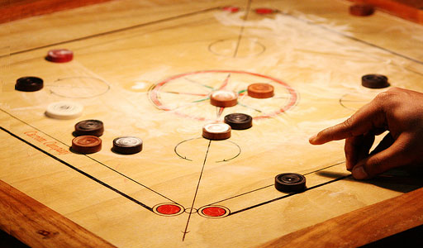

Figure 2 A basic Carrom game in play. The objective is to flick the game pieces into holes located at each corner of the board. Image taken from https://s-media-cache-ak0.pinimg.com/originals/00/47/35/00473582cc85d8b5e4e89a2d2f732cf8.jpg

Figure 3 The popular video game, "Block Breaker". Players must bounce the ball around the field of play and destroy the colored blocks located at the top of the screen. Image taken from https://screenshots.en.sftcdn.net/en/scrn/3339000/3339381/block-breaker-3-06

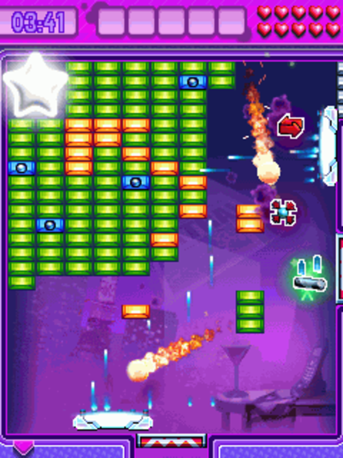

The board will be rectangular in shape, with each side designated as the player’s area. In the area will be a painted circular region in which the game pieces will be assembled. The game pieces can be assembled at random, or at the will of the player. The objective of the game will be to flick a game piece, called the Striker, at the opposing players game pieces in an effort to knock them out of the painted circle. If a piece is knocked out, it is removed from play. Players take turns flicking and knocking down game pieces until the one of them has no more pieces left. The player with the last piece standing wins. Adding to the challenge of the game, there are two walls in place in the middle of the game board for each player to work around. The walls feature two medium-sized openings on either side of the board, with a smaller-sized opening in the middle. Sketches of the concepts are listed in the .

We believe the concept for the game satisfies several of the customer need statements. For instance, each player will receive the same number of game pieces at the beginning of play as well as identical areas for the pieces to reside in. This means that neither player will have an unfair competitive advantage. Furthermore, the rules are simple enough to explain and follow, satisfying the need for the game to be simple. Since the game can be played be either two people, or one person in a “practice-like” setting, two more needs are satisfied; the ability to play competitively as well as featuring a one-player game. Finally, team play is allowed by simply allowing each side to switch players when it’s time their turn. This allows for competitive team play, which was listed as another need.

With the system-level concept set, the next step was for each team member to identify and analyze the individual aspects of the game. It was clear to the team that the four aspects that were central to gameplay were: the ability for the Striker to bounce off of the walls, the Striker game piece itself, the other game pieces, and the game board. Using both the need statements as well as the mission statement, the individual parts had at least three concepts generated for each. We felt as though three was an appropriate number as it allowed multiple avenues to be explored, while still retaining a good level of specificity.

## Individual Aspects

### Ability for Striker to Bounce

The primary way for the player to hit the game pieces with the Striker is by bouncing it off the outer walls of the game board, around the middle walls. This idea is illustrated in Figure 18. The Striker needs to carry its velocity from the initial flick through the bounce in order to hit the game pieces with enough force to knock them over. While an elastic collision can be achieved without any further aid, we felt as though this representing a good opportunity to add to the phenomenon, as well as add aesthetics. Along with that, the team felt as though some sort of barrier was needed to separate the Striker from the walls, so wear and tear would be kept to a minimum. A classic example of the concept in action would be the protective felt covering on a billiards table, shown in Figure 4 Billiards tables exemplify both elastic collisions, as well as protective covering on the walls of the table. Both aspects are wanted in the design. Image taken from http://www.livescience.com/images/i/000/067/125/original/pool-table.jpg?interpolat.

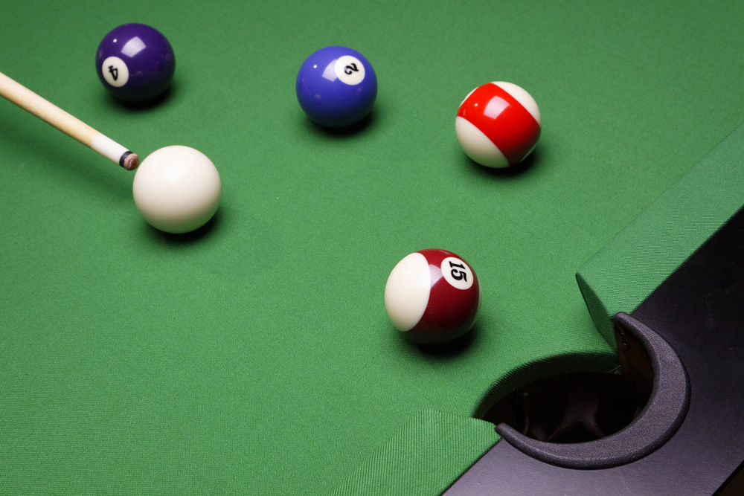

Figure 4 Billiards tables exemplify both elastic collisions, as well as protective covering on the walls of the table. Both aspects are wanted in the design. Image taken from http://www.livescience.com/images/i/000/067/125/original/pool-table.jpg?interpolat

It should be noted that, while protective bumper that maximizes the elastic collision is the desired concept, the bumper itself was not simply limited to the walls of the game board. The team decided that the Striker could house this bumper as well. Such an option would be cheaper and easier to manufacture, in contrast to supplying material around the entire board.

With that, we generated a list of concepts. They were: using material similar to that of a resistance band and wrapping it around the perimeter of the board, encasing the striker in the same material used to make bouncy balls, and surrounding the perimeter of the game board with an inflatable plastic. Rough sketches are shown in Figure 14.

In order to assess each concept, a concept-screening matrix was used. The selection criteria were based off of both perceived needs from customer statements, as well as what the team thought was important in the function of the concept. A reference concept, billiards table padding, was selected as the base value. Since this concept is already in use, and function well enough, we knew that the concepts could be appropriately rated against it. The results of the concept-screening matrix are shown in Table 7.

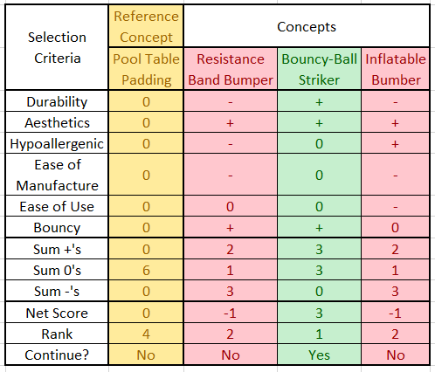

Table 7 Concept-Screening matrix used to select the final concept for the "Bumper"

As shown in the table, the reference concept’s values were denoted with 0’s in order to compare. If the concept performed better in terms of the selection criteria, a + was given. If it performed at the same level, or less than, a 0 and – were given, respectively. At the end of the screening, the +’s, 0’s, and –‘s, were summed to achieve the net score. The concept that performed the best was the idea of surround the Striker with a bouncy-ball material. Such an idea could provide improved aesthetics to the game, as well as the ability to buy and trade Strikers with other players.

The resistance band bumper concept performed well in the field of aesthetics, and being bouncy enough for the Striker, however the team felt as though manufacturing and assembling of this would be very difficult and costly. Furthermore, if a child is allergic to latex they would be excluded from play, which directly conflicts with the desire to create a game in which everyone is involved.

The inflatable bumper idea had promise in the realm of hypoallergenic solutions. Ultimately, however, the team felt as though the design was overly complex and would be cumbersome to the player. For instance, if the bumper ran out of air, the players would have to stop play and re-inflate it. Even if the nozzle was positioned in an easy-to-reach location, we felt as though the players would be increasingly annoyed at the prospect of having to stop playing their game.

### Striker Game Piece

Specifications of the striker are:

1. The striker should be strong enough to hit the game pieces and should bounce back.
2. The surface of the striker should be circular since the game board is rectangular as it reduces the air friction.
3. It should have exact weight to maintain the force to hit the pieces.

The striker is decorated and personalized in the other games but not in ours since we haven’t started yet.

1. Marble striker:

There is little friction compared to the other strikers. It is little heavy compared to other

Strikers and therefore we can hit the game pieces accordingly.

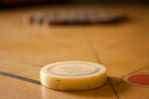

Figure Marble Striker image taken from https://pixabay.com/en/carrom-game-table-game-striker-167023/

1. Wooden striker:

It is less in weight and if not properly polished it increases the friction between the surface of the striker and the board.



Figure Wooden Striker. Image taken from http://www.precisesports.com/how_to_play.htm

1. Plastic striker:

It is highly unstable because of less weight and have friction because of the force applied.

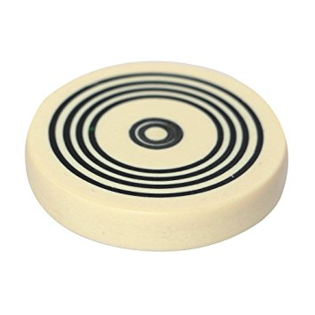

Figure Taken from http://ecx.images-amazon.com/images/I/71uvSZ3Ff8L._SY355_.jpg

After assessing the striker, the team decided to use marble striker as it possesses high sturdiness, exceptional striking strength and high durability and smooth finishing. This is shown in Table 8.



Table 8 Screening matrix for Striker concepts

### Other Game Pieces

The specifications of pieces that the Striker hits:

1. The pieces that the striker hits should be light enough to be knocked out of the circle.
2. The pieces should be safe if they get outside of the board and hit someone.
3. They should present a challenge.

We suggest three concepts of the pieces

1. 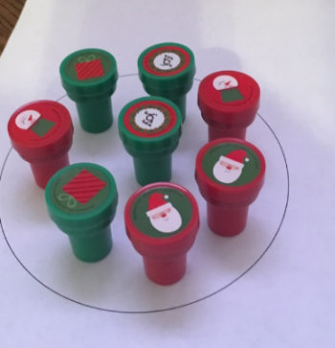Figure 8 illustrates the first selection of the pieces that the “Striker” hits. It made from plastic and they have 3.5 cm length and 10 grams weight. The number of pieces in the circle are 8 pieces.

Figure 8

1. Figure 9 illustrates the second choice of the pieces that the striker hits. It made from wood and they have 5 cm length and 10 grams weight.

In the first and second choice, the player tries to fall dawn a piece. When the sticker hits one piece, there is an opportunity this piece hits and fall dawn another piece.

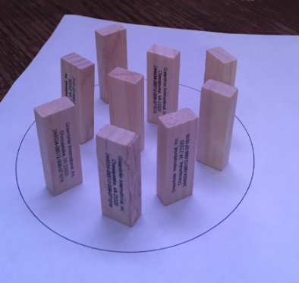

Figure 9

1. The third choice of the pieces that the striker hits is to put number of pieces of dices in the circle. This choice is more competitive and challenge since the player need to kick the piece outside the circle.

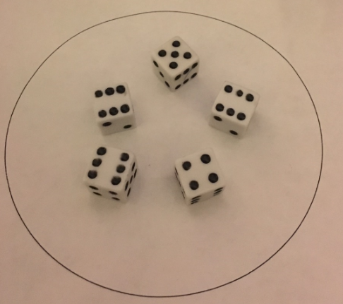

Figure



Table 9 Concept-Screening matrix used to select the final concept for pieces that the “Striker” hits final concept for pieces that the “Striker” hits

* Game Board

From the survey, we established five criteria on which the product material would be made of:

* Ease of handling
* Portability
* Durability
* Bouncy
* Manufacturing cost

Easy handling and durability is of less importance compared to other features. From the survey, it is clear that the players prefer a game over another for its game play. Therefore, these features are given less weightage. On the other hand, cost is given the high weightage. From the survey, we could see that customers don’t spend a huge sum on a board game. Therefore, materials are selected giving preference to cost of the game.



Table 10 Weighted scoring matrix for the game board concepts

From the concept selection matrix, we conclude that the board is going to be made of plywood and the block in the middle is going to be made of plastic, which is detachable as it eases portability.

# Final marketing plan

Mind bogglers is a simple, fun board game that combines both Carrom and games such as Block Breaker. Its primary objective is to provide entertainment to a wide range of users. The marketing plan is divided into multiple levels to satisfy customer goals and requirements.

**Goals and objectives:**

Mind boggler is a board game for players of age 10 and above. The age goal and other factors were decided based on surveys conducted by the team members.

**Sales objectives:**

We identified price as being an important factor to the overall success of the game in the market, and based on customer feedback from survey results, that price will be set at no more than $30.

**Packaging:**

The game board is rectangular in shape and is portable. The game pieces are kept inside a box to retard any tendency to lose the pieces. The team is considering several designs and images on the box to attract the children, but has not yet decided on a final design.

**Licensing and copyright act:**

Copyright is a form of protection which is provided by the laws to the authors of original works of authorship. This protection is available to both the published and unpublished works. The game that is created by our team is not similar to any of the other board games. If our game resembles any other type of other board game, we must make sure the modifications do not violate the copyright criteria of the other games. Due to the amount of capital required, a patent will not be filed immediately following the launch. Instead, the team will try and market the product to major companies, such as Hasbro and Parker Brothers, that have adequate resources to pursue it.

**Advertising and promotion:**

Advertising plays a vital role in the success of the product. Our team will use web-based sites and pop-up ads that will mainly run on websites such as twitter, Google, YouTube, and Facebook.

# Test Plan

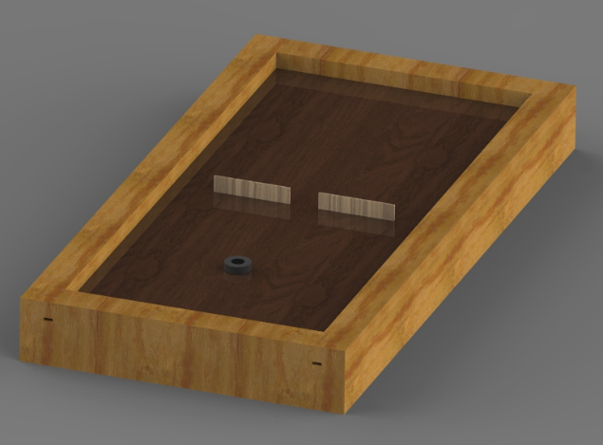The final prototype will be made out of wood, most likely pine purchased from Home Depot to save on initial cost. The final product will be made out of pine as well, although it can be stained to give it better aesthetic appeal. An artist’s representation of this is shown in Figure 11.

Figure 11 CG render of the final product

To test the prototype of the Mind Boggler, a focus group will be used. Twenty individuals, ranging from 10 years of age to 35 years of age will be selected. The participants can either be members of the original survey endeavor, or volunteers. They will be divided into groups of four, with one group playing the game for a few moments while the other groups watch. This will allow them to formulate strategies that may help them during their turn of play.

When finished, the subjects will come together in a group setting to discuss the outcome. They will be asked questions regarding the aesthetics, gameplay, and general observations of the game. The questions will be both quantitative with lower-numbered answers meaning good feedback and vice versa, such as “rank your level of enjoyment from 1 (a lot of fun) to 10 (no fun at all)”, and qualitative, such as “please describe your least-favorite moment while playing”. The quantitative questions will come in the form of a written survey, while the qualitative questions will simply be asked and opened for discussion. In that instance, the responses will be recorded, provided the subjects give consent.

Our goal is to receive above-average results quantitatively (i.e., greater than a 4) on most of the questions. If the general consensus is negative, the product will be reexamined from a conceptual level to better align with the new feedback. If it is favorable, certain elements will be exemplified to increase enjoyment of the game. The selected elements will come both from the quantitative questions, as well as the qualitative answers. The entire process will be repeated until our original goal is met. We hope to repeat no more than three times.

# Appendix

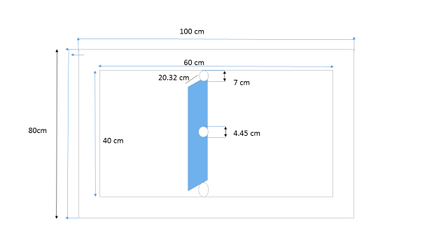The dimensions of the board and the plastic block in the middle are given below.

Figure Dimensions of the game board

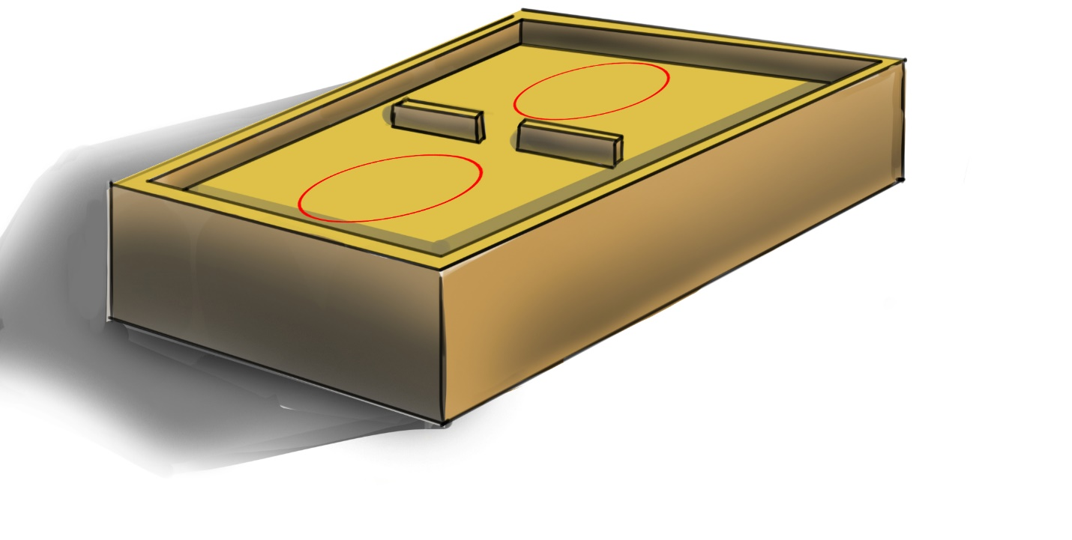

Figure Conceptual board design

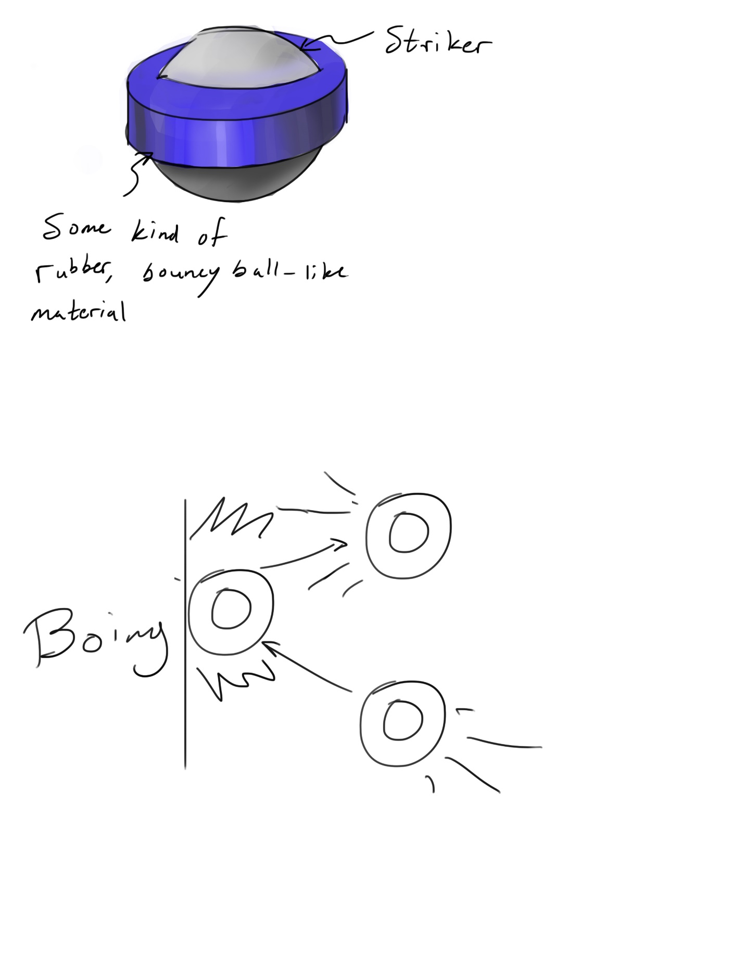

Figure Bouncy-ball conceptual sketch

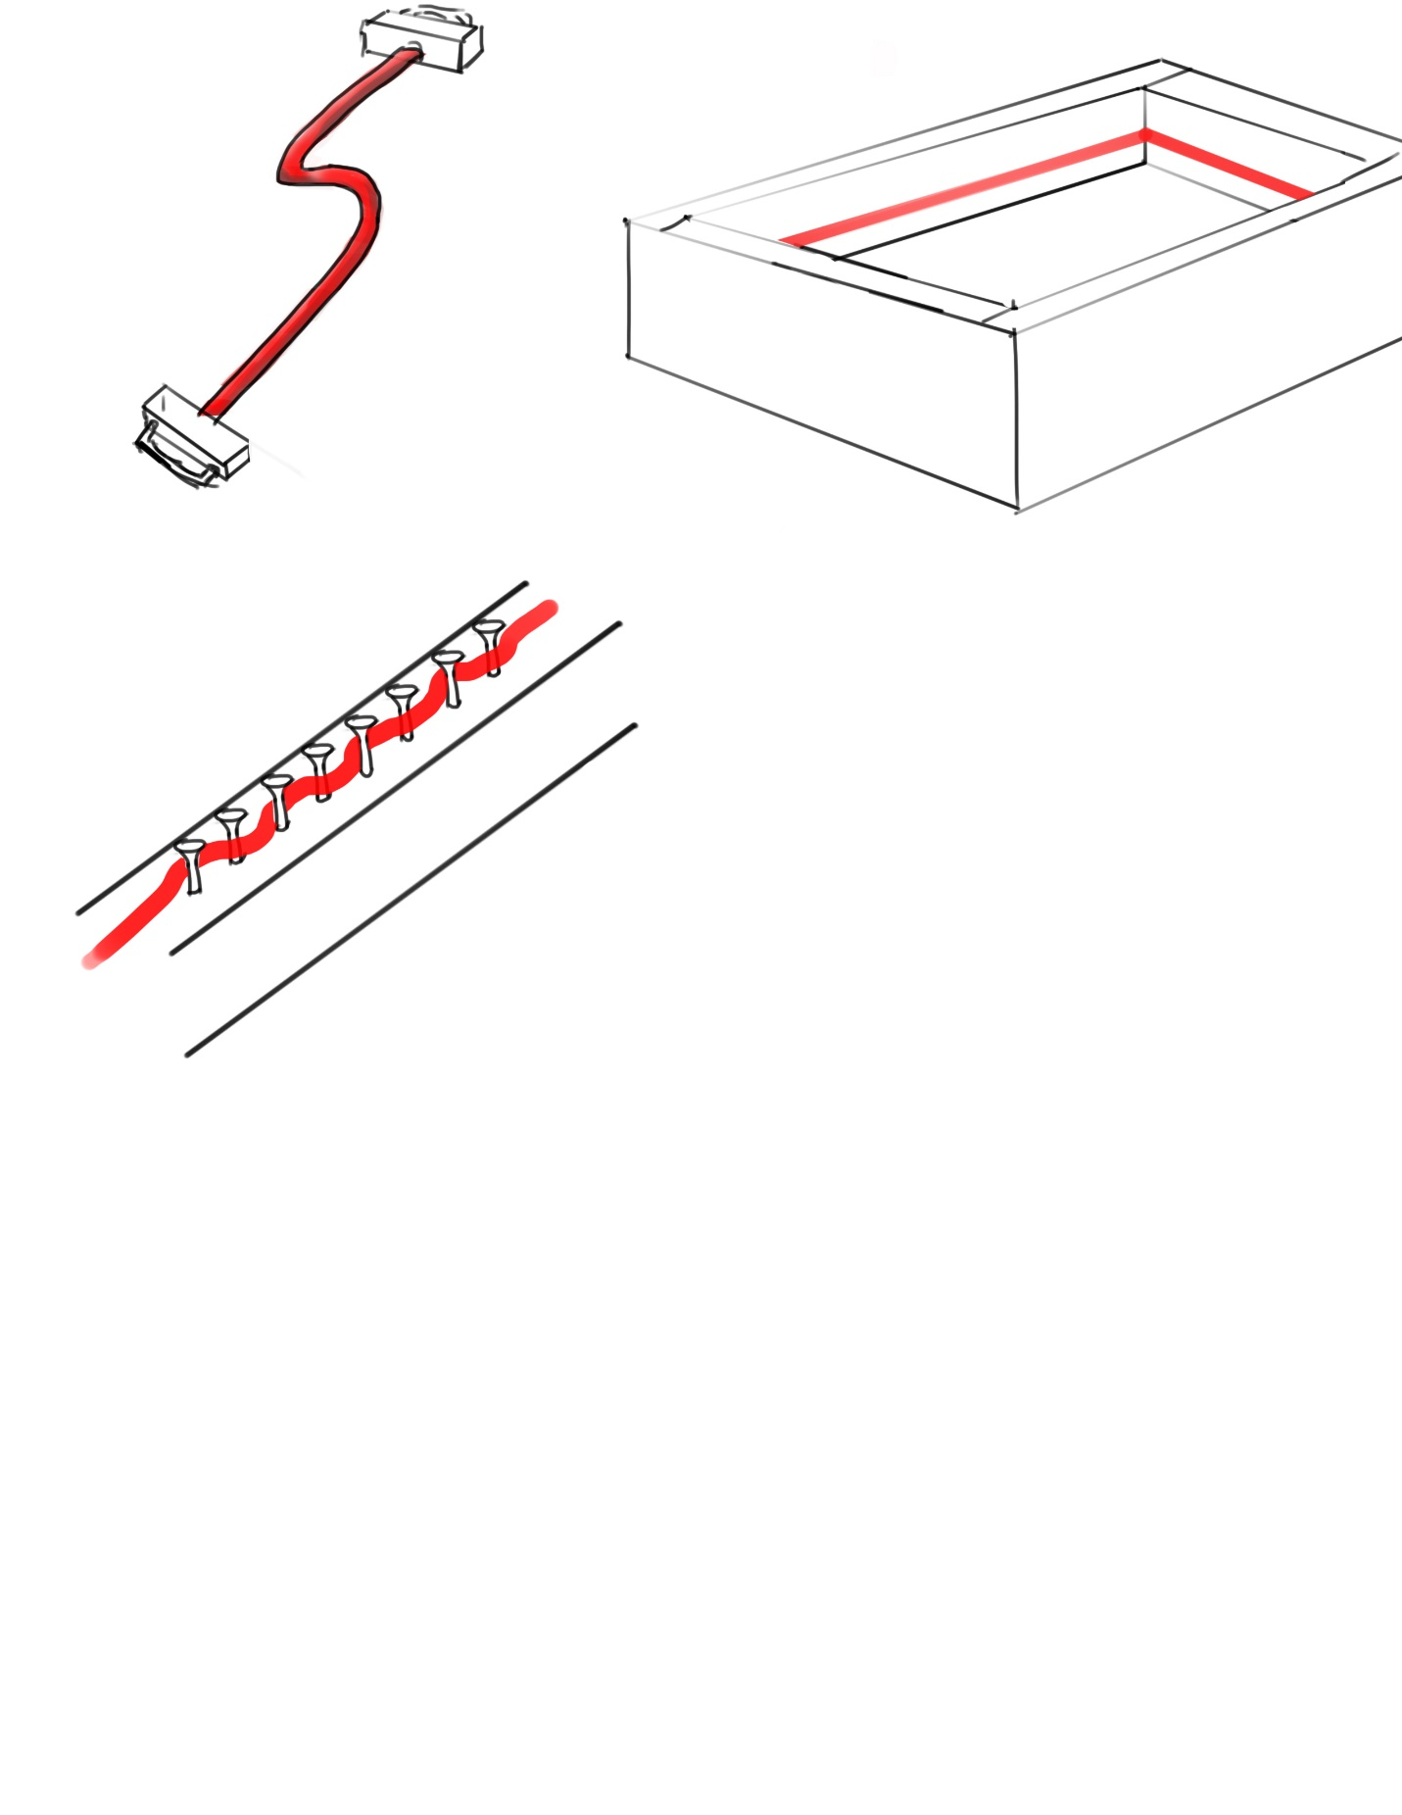

Figure Resistance band conceptual image

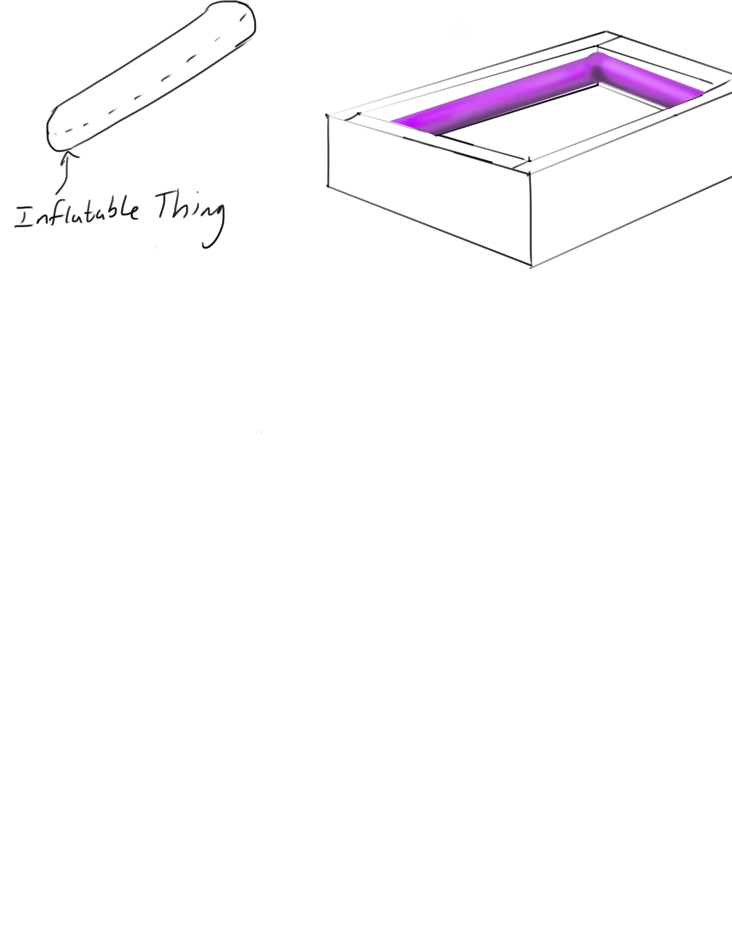

Figure Inflatable balloon conceptual sketch

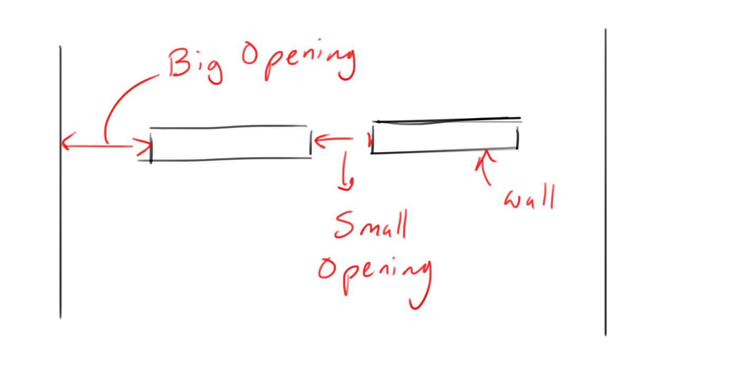

Figure Illustrating the spaces in between the walls

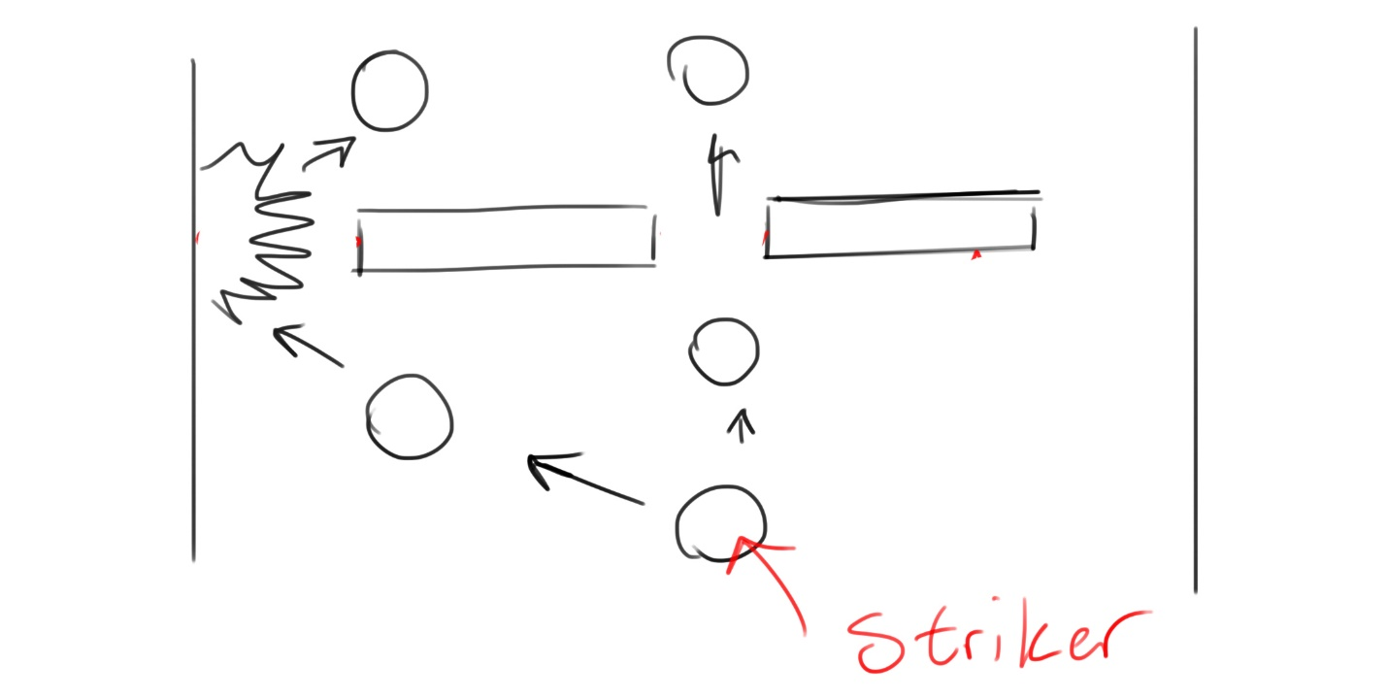

Figure Illustrating how the Striker moves around the walls